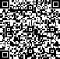[2009] 105 









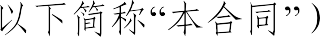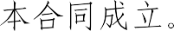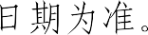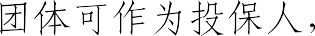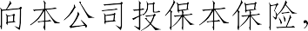

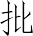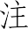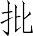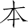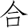

 



 30  

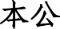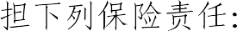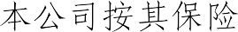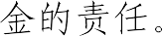

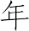



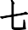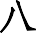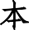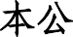

 1

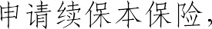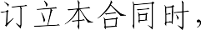

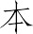

 

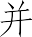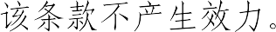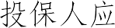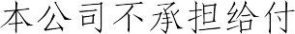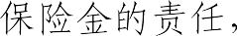

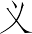

 30 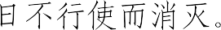





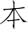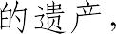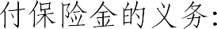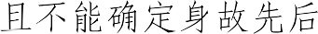



   



 10 

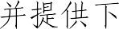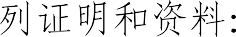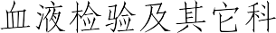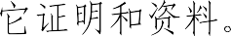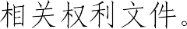



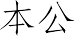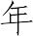

 



5  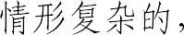 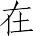 30 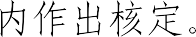 

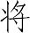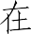

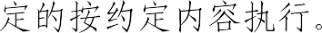

10  

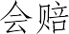

  3 



 60



 2 



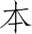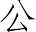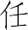

  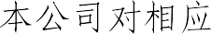

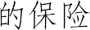

75% 



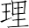

1  





2  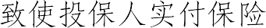

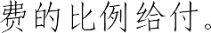

3  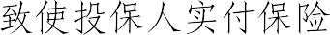





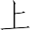

 

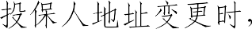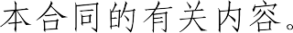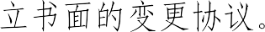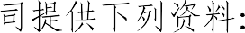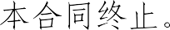

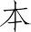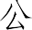

  30 

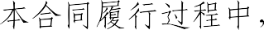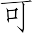

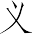

  5  5  

  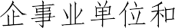

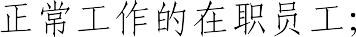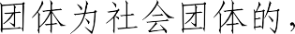

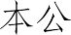

 30 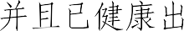

 23  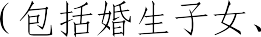 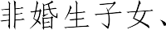

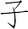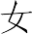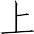

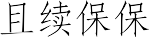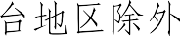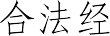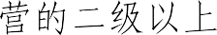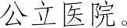

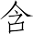

 

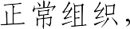

  ICD-10  



# 1

**2** 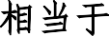 **Binet ** **A **

**3** 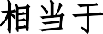 **Ann Arbor ** **I **

**4 **  

# 5 TNM T1N0M0 6

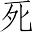

1  

2 

3  





4 90  

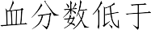 50%





 180 



1 

2 

3    

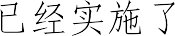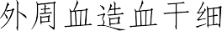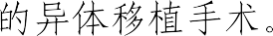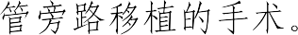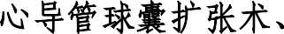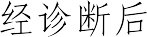

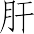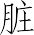

 90  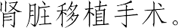

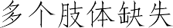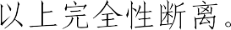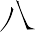

1 

2 

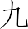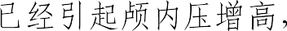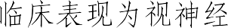3 B  4 

 CT  MRI 

PET  

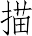

1  



2 

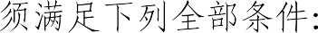

1 

2 

3 

4 





  180 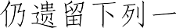





1 

2 

3    





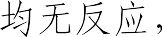  Glasgow coma scale

 5  5 



  96  

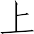





 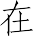 500

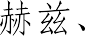 1000  2000 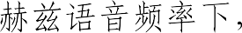 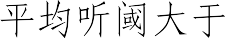 90



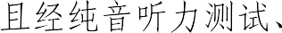 

 **0 ** **3 ** 

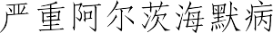





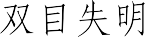

1 

2 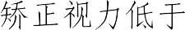 0.02





3 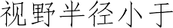 5





180





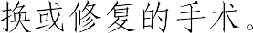







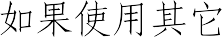

 180 







 CT 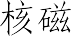

 MRI  PET 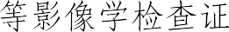

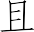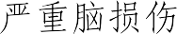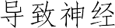

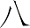

  CT 

MRI  PET 

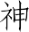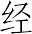

  180 



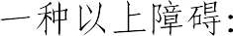

1 

2 

3    

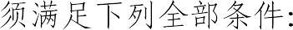

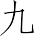

1 

2    

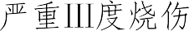



 

20% 20%  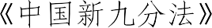 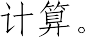

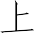

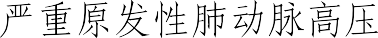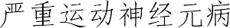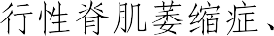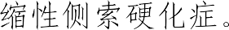



12  



 **0 ** **3 ** 

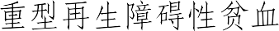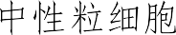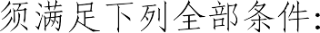



1

2

1 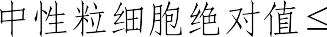

2 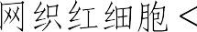 1%

0.5

109 /L

3 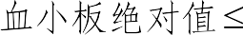 20 109 /L

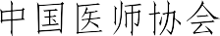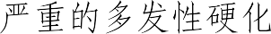

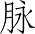

  CT 



 180 

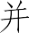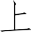



1  

2 

3  

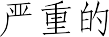 1 



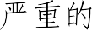 1 

  180  

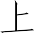

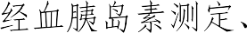 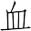 C  C     

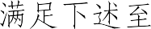

 1

1 

2 

3 

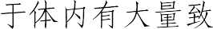

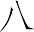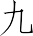

1  4

1 



2 

3 

4 

5 

6  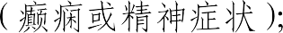

7 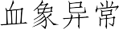 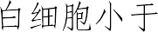 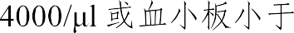 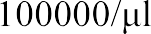

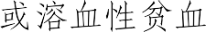

2  2



1  dsDNA 

2  Sm 

3 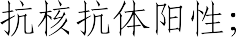

4  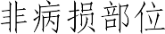 

5 C3 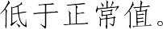

3

30ml

 

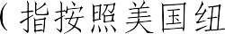



*  180

 





* 

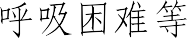



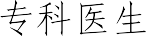

1  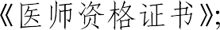

2  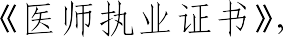 



3 

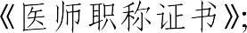

4 

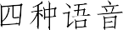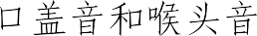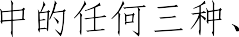

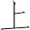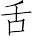

  



1  

2   



3  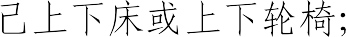



4  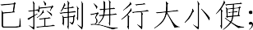

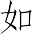

5    

6   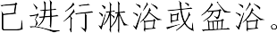



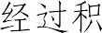

 180 

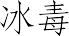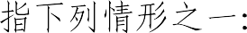

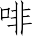

1 

2 

3 

4   

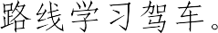

1 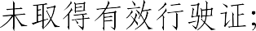

2 

3 

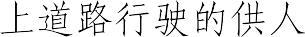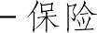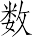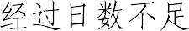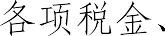

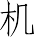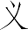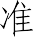

   25%

 



